***Section* 1.3 – Volumes by Slicing**

If we want to find a volume of a solid *S* and if the cylindrical solid has known base area *A* and height *h*, then the volume of the cylindrical solid is



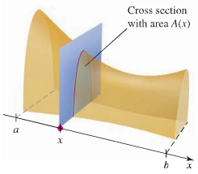 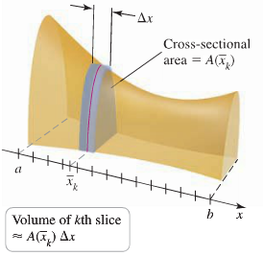

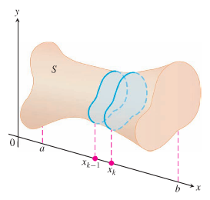

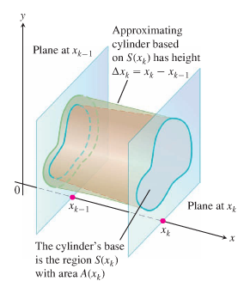

***Definition***

The volume of a solid of integrable cross-sectional area  from *x* = *a* to *x* = *b* is the integral of *A* from *a* to *b*



***Calculating the volume of a solid***

1. Sketch the solid and a typical cross-section
2. Find a formula for , the area of a typical cross-section
3. Find the limits of integration
4. Integrate  to find the volume

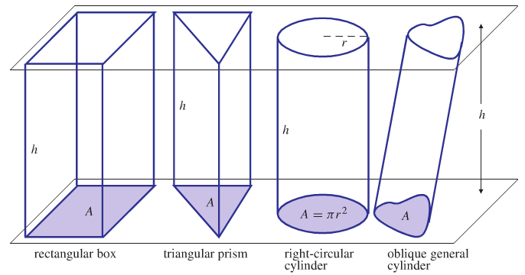

***Example***

A pyramid 3*m* high has a square base that is 3*m* on a side. The cross-section of the pyramid perpendicular to the altitude ***x*** *m* down from the vertex is a square ***x*** *m* on a side. Find the volume of the pyramid.

***Solution***

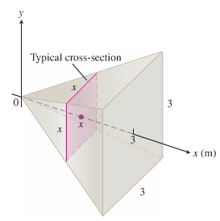The area of the square is given by the formula: 

The volume: 









***Example***

A curved wedge is cut from a circular cylinder of radius 3 by two planes. One plane is perpendicular to the axis of the cylinder. The second place crosses the first plane at a 45° angle at the center of the cylinder. Find the volume of the wedge.

***Solution***

The base of the cylinder is a circle .

Since the second plane cut the base at the cylinder at the center, therefore, the base of the wedge is semi-circle. .

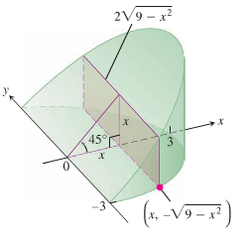When we slice the wedge by a plane perpendicular to the axis of the cylinder, we obtained a cross-section at *x* which is a rectangle of height *x*.

The area of this cross-section is: 





The rectangles run from *x* = 0 to *x* = 3, so



 









**Solids of Revolution: The Disk Method**

The solid generated by rotating (or revolving) a plane region about an axis in its plane is called a ***solid of revolution***.

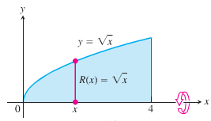 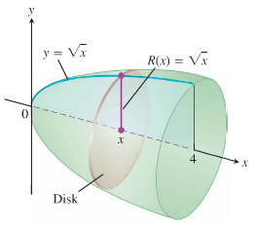

The cross-sectional area  is the area of a disk of radius , the distance of the planar region’s boundary from the axis of revolution. The area then



And the volume 



***Example***

The region between the curve , and the *x*-axis is revolved about the *x*-axis to generate a solid. Find its volume.

***Solution***













***Example***

The circle  is rotated about *x*-axis to generate a sphere. Find its volume

***Solution***

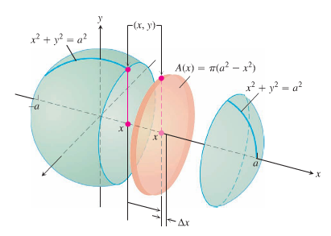











**Volume by Disks for Rotation about the *y*-axis**





***Example***

Find the volume of the solid generated by revolving the region between the *y*-axis and the curve  about the *y*-axis.

***Solution***

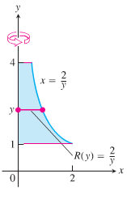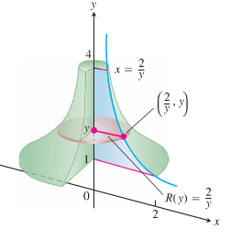













***Example***

Find the volume of the solid generated by revolving the region between the parabola  and the line *x* = 3 about the line *x* = 3.

***Solution***

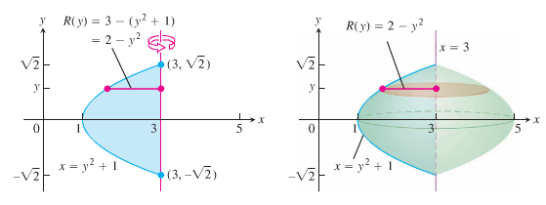



When 







 ***Even Function***









**Solids of Revolution: The *Washer Method***

If the region we revolved to generate a solid does not border on or cross the axis of revolution, the solid has a hole in it. The cross-sections perpendicular to the axis of revolution are ***washers*** instead of disks.

The dimensions of a typical washer are:

Outer radius: 

Inner radius: 

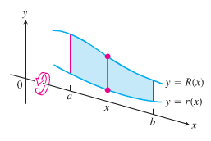

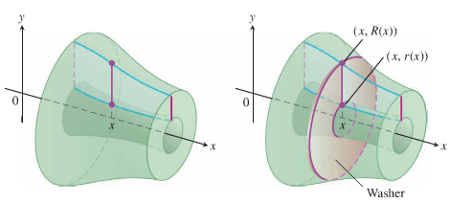

The washer’s area is:



The washer’s volume:





***Example***

The *R* be the region in the first quadrant bounded by the graphs of  and . Which is the greater, the volume of the solid generated when *R* is revolved about the *x-*axis or the *y-*axis?

***Solution***

About the ***x-axis***

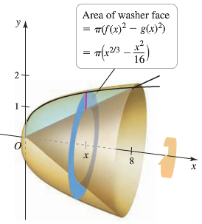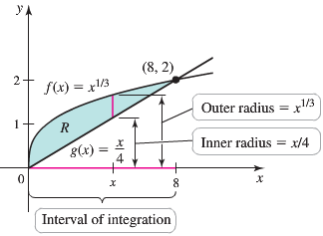





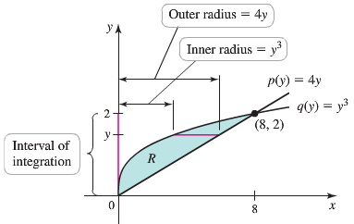







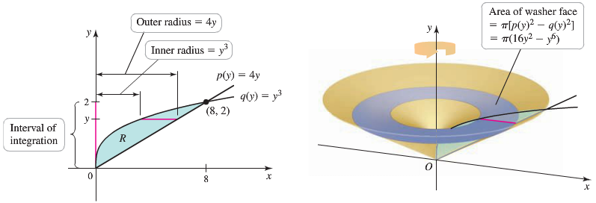 







About the ***y-axis***



















The region that is revolving about the ***y-axis*** produces a solid of greater volume.

***Example***

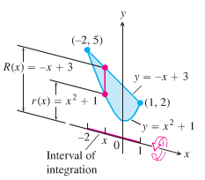The region bounded by the curve  and the line *y* = −*x* + 3 is revolved about the *x*-axis to generate a solid.

Find the volume of the solid.

***Solution***



 ***Solve for x***





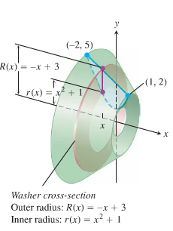 















***Example***

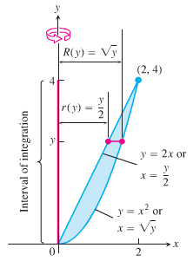The region bounded by the parabola  and the line *y* = 2*x* in the first quadrant is revolved about the *y*-axis to generate a solid.

Find the volume of the solid.

***Solution***











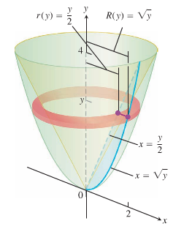









***Example***

The region *R* is bounded by the graphs of  and  between  and .

What is the volume of the solid that results when *R* is revolved about the *x-*axis?

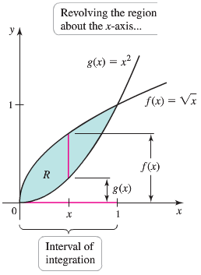***Solution***











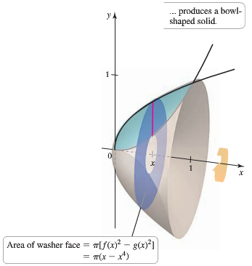 

***Exercises Section* 1.3 – Volume by Slicing**

Find the volume of the solid formed by revolving the region about the 

|  |  |
| --- | --- |
|  |  |
|  |  |
|  |  |
|  |  |
|  |  |
|  |  |

Find the volume of the solid formed by revolving the region about the 

|  |  |
| --- | --- |
|  |  |
|  |  |
|  |  |
|  |  |

1. Find the volumes of the solids generated by revolving the region by the graphs of the equations about the given lines. 

|  |  |  |  |
| --- | --- | --- | --- |
| 1. the | 1. the | 1. the line | 1. the line |

1. Find the volumes of the solids generated by revolving the region by the graphs of the equations about the given lines. 

|  |  |  |  |
| --- | --- | --- | --- |
| 1. the | 1. the | 1. the line | 1. the line |

1. Find the volumes of the solids generated by revolving the region by the graphs of the equations about the given lines. 

|  |  |
| --- | --- |
| 1. the | 1. the line |

1. Find the volumes of the solids generated by revolving the region by the graphs of the equations about the given lines. 

|  |  |
| --- | --- |
| 1. the | 1. the line |

1. The solid lies between planes perpendicular to the *x*-axis at *x* = 0 and *x* = 4. The cross-sections perpendicular to the axis on the interval  are squares whose diagonals run from the parabola  to the parabola . Find the volume of the solid.
2. The solid lies between planes perpendicular to the *x*-axis at *x* = 0 and *x* = 1. The cross-sections perpendicular to the *x*-axis between these planes are circular disks whose diameters run from the parabola  to the parabola . Find the volume of the solid.
3. The base of the solid is the region in the first quadrant between the line  and the parabola . The cross-sections of the solid perpendicular to the *x*-axis are equilateral triangles whose bases stretch from the line to the curve. Find the volume of the solid.
4. The solid lies between planes perpendicular to the *x*-axis at *x* = 0 and *x* = 6. The cross-sections between these planes are squares whose bases run from the *x*-axis up to the curve . Find the volume of the solid.

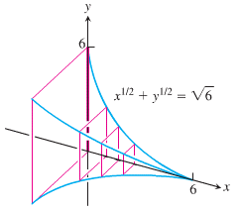

1. The solid lies between planes perpendicular to the *x*-axis at *x* = −1 and *x* = 1. The cross-sections perpendicular to the *x*-axis are circular whose diameters run from the parabola  to the parabola . Find the volume of the solid.

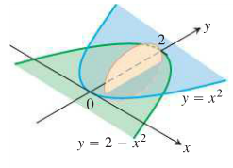

1. The solid lies between planes perpendicular to the *x*-axis at *x* = −1 and *x* = 1. The cross-sections perpendicular to the axis between these planes are squares whose bases run from the semicircle  to the semicircle . Find the volume of the solid.
2. The base of a solid is the region between the curve  and the interval [0, π] on the *x*-axis. The cross-sections perpendicular to the *x*-axis are

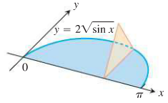

1. Equilateral triangles with bases running from the *x*-axis to the curve as shown
2. Squares with bases running from the *x*-axis to the curve. Find the volume of the solid.
3. The base of the solid is the disk . The cross-sections by planes perpendicular to the y-axis between *y* = −1 and *y* = 1 are isosceles right triangles with one leg in the disk.

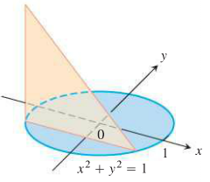

1. Find the volume of the given tetrahedron. (***Hint***: Consider slices perpendicular to one of the labeled edges)

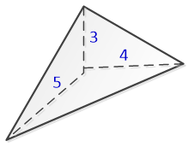

1. Find the volume of the solid of revolution

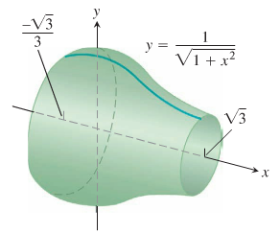

1. Find the volume of the solid generated by revolving the region bounded by  and the lines  about the *x*-axis.
2. Find the volume of the solid generated by revolving the region bounded by  and the line  about the *x*-axis.
3. Find the volume of the solid generated by revolving the region bounded by  and the lines  about the *x*-axis.
4. Find the volume of the solid generated by revolving the region bounded by  and the lines  about the *x*-axis.
5. Find the volume of the solid generated by revolving the region bounded by  and the lines  about the *y*-axis.
6. Find the volume of the solid generated by revolving the region bounded by  and the lines  about the *x*-axis.
7. Find the volume of the solid generated by revolving the region bounded by  and the lines  about the *x*-axis.
8. Find the volume of the solid generated by revolving the region bounded by  and the lines  about the *y*-axis.
9. What is the volume of the solid whose base is the region in the first quadrant bounded by , , and the *x-*axis, and whose cross sections perpendicular to the base and parallel to the *y-*axis are squares?
10. What is the volume of the solid whose base is the region in the first quadrant bounded by , , and the *x-*axis, and whose cross sections perpendicular to the base and parallel to the *y-*axis are semicircles?
11. What is the volume of the solid whose base is the region in the first quadrant bounded by , , and the *y-*axis, and whose cross sections perpendicular to the base and parallel to the *x-*axis are square?
12. The region bounded by the curves  and  is revolved about the *x-*axis. What is the volume of the solid that is generated?
13. The region bounded by the curves , , and the *y-*axis is revolved about the *x-*axis. What is the volume of the solid that is generated?
14. The region bounded by the curves , , for  is revolved around the *x-*axis. What is the volume of the solid that is generated?
15. The region bounded by the graph  and  is revolved about the line  . What is the volume of the resulting solid?
16. Find the volume of a solid ball having radius *a*.
17. You are designing a wok frying pan that will be shaped like a spherical bowl with handles. A bit of experimentation at home persuades you that you can get one that hold about 3 *L* if you make it 9 *cm* deep and give the sphere a radius of 16 *cm*. To be sure, you picture the wok as a solid of revolution, and calculate its volume with an integral. To the nearest cubic centimeter, what volume do you really get? 

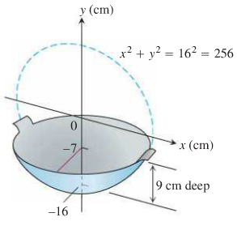

1. A curved wedge is cut from a circular cylinder of radius 3 by two planes. On plane is perpendicular to the axis of the cylinder. The second place crosses the first plane at a 45° angle at the center of the cylinder. Find the volume of the wedge.
2. Find the volume of the solid generated by revolving the region bounded by  and the lines , *x* = 4 about the line *y* = 1.
3. Let *R* be the region bounded by . Use the disk method to find the volume of the solid generated when *R* is revolved about *y-*axis.
4. Find the volume of the solid of revolution bounded by  revolved about the *x-*axis. Sketch the region
5. Find the volume of the solid of revolution bounded by revolved about the *x-*axis. Sketch the region
6. The solid with a circular base of radius 5 whose cross sections perpendicular to the base and parallel to the *x-*axis are equilateral triangles. Use the general slicing method to find the volume of the solid.

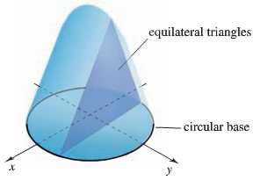

1. The solid whose base is the region bounded by  and the line  and whose cross sections perpendicular to the base and parallel to the *x-*axis squares. Use the general slicing method to find the volume of the solid.

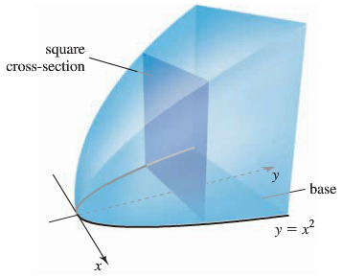

1. A circular cylinder of radius *r* and height *h* whose curved surface is at an angle of  . Use the general slicing method to find the volume of the solid

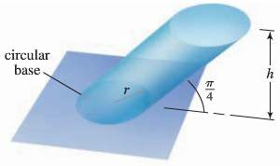

1. Let *R* be the region bounded by . Use the disk method to find the volume of the solid generated when *R* is revolved about *x-*axis.

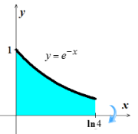

1. Let *R* be the region bounded by . Use the disk method to find the volume of the solid generated when *R* is revolved about *x-*axis,

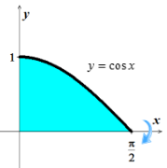

1. Let *R* be the region bounded by . Use the disk method to find the volume of the solid generated when *R* is revolved about *x-*axis.

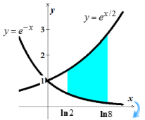

1. Let *R* be the region bounded by . Use the disk method to find the volume of the solid generated when *R* is revolved about *y-*axis.

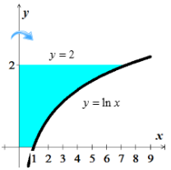

Find the volume of the solid generated by revolving the region boubbded by the graphs of the equations about the line 

|  |  |
| --- | --- |
|  |  |

Find the volume of the solid generated by revolving the region boubbded by the graphs of the equations about the line 

|  |  |
| --- | --- |
|  |  |

1. Find the volume generated by rotating the given region  about the specified line.

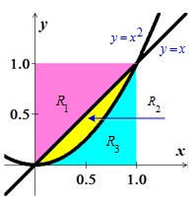

|  |  |  |
| --- | --- | --- |
|  |  |  |

1. Let 

Find the volume of the solid formed when the region bounded by the graph of *f*, the *x-*axis, and the line  is revolved about the *x-*axis

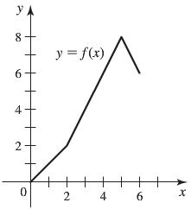 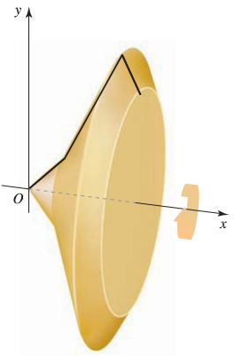

1. Consider the solid formed by revolving the region bounded by , , and  about the 
2. Find the value of *x* in the interval  that divides the solids into two parts of equal volume.
3. Find the values of *x* in the interval  that divide the solids into three parts of equal volume.
4. The arc of  on the interval  is revolved about the line 

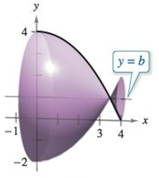

1. Find the volume of the resulting solid as a function of *b*.
2. Graph the function in part (*a*), and approximate the value of *b* that minimizes the volume of the solid.
3. Find the value of *b* that minimizes the volume of the solid, and compare the result with the answer in part (*b*).
4. Prove that if two solids have equal altitudes and all plane sections parallel to their bases and at equal distances from their bases have equal areas, then the solids hace the same volume.

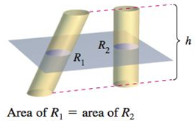



1. Find the volumes of the solids whose bases are bounded by the graph of  and , with the indicated cross sections taken perpendicular to the 

|  |  |
| --- | --- |
| 1. Squares | 1. Rectangles of height 1 |
|  |  |

1. Find the volumes of the solids whose bases are bounded by the circle , with the indicated cross sections taken perpendicular to the 

|  |  |
| --- | --- |
| 1. Squares | 1. Equilateral triangles |
|  |  |
| 1. Semicircles | 1. Iscosceles right triangles |
|  |  |

1. Find the volume of the solid of intersection (the solid common to both) of the two right circular cylinders of radius *r* whose axes meet at right angles.

|  |  |
| --- | --- |
|  |  |
| Two intersecting cylinders | Solid of intersection |

1. The solid shown in the figure has cross sections bounded by the graph  where .
2. Describe the cross section when  and .
3. Describe a procedure for approximating the volume of the solid.

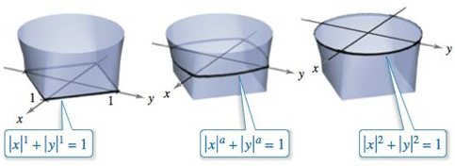

1. Two planes cut a right circular cylinder to form a wedge. One plane is perpendicular to the axis of the cylinder and the second makes an angle of *θ* degrees with the first.

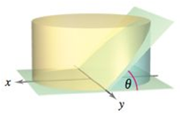

1. Find the volume of the wedge if .
2. Find the volume of the wedge for an arbitrary angle *θ*. Assuming that the cylinder has sufficient length, how does the volume of the wedge change as *θ* increases from 0° to 90°?
3. For the given torus (donut).

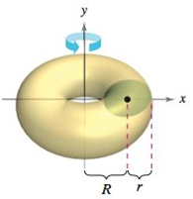

1. Show that the volume of the torus is given by the integral



1. Find the volume of the torus
2. Consider a right-circular cylinder of diameter 1. Form a wedge by making one slice parallel to the base of the cylinder completely through the cylinder, and another slice at an angle of 45° to the first slice and intersecting the first slice at the opposite edge of the cylinder. Find the volume of the wedge.

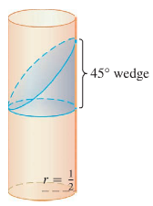

1. A martini glass in the shape of a right-circular cone of height *h* and semi-vertical angle α is filled with liquid. Slowly a ball is lowered into the glass, displacing liquid and causing it to overflow.

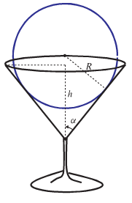

Find the radius *R* of the ball that causes the greatest volume of liquid to overflow out the glass.

1. A 45° notch is cut to the center of a cylindrical log having radius 20 *cm*. One plane face the notch is perpendicular to the axis of the log. What volume of wood was removed from the log by cutting the notch?

